Azure Machine Learning (Azure ML) Standards & Best Practices
Audience: Enterprise Azure ML, Data Science, Data Engineering, MLOps, Platform & Security Teams
Scope: This document defines enterprise-grade standards, best practices, and reference architectures for designing, developing, securing, deploying, and operating Machine Learning solutions using Azure Machine Learning.

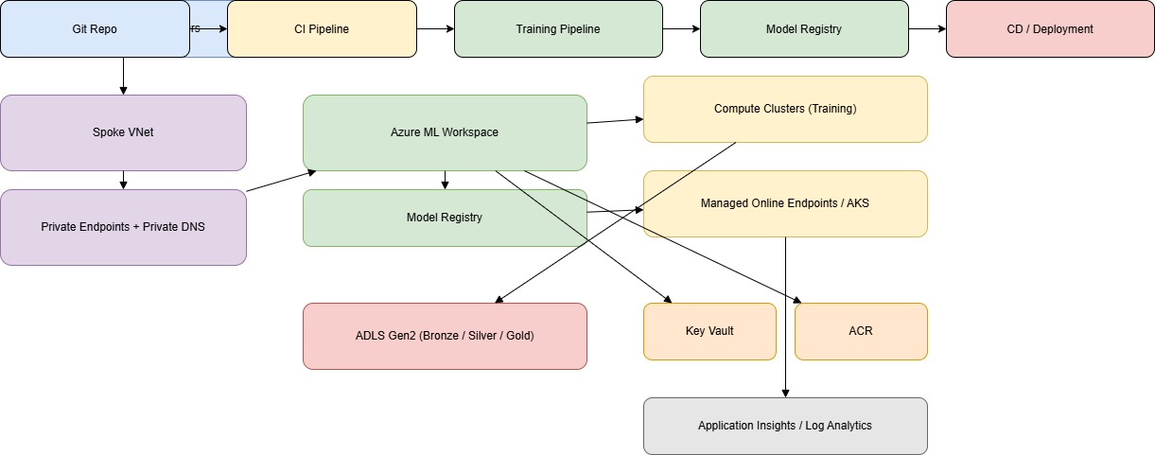1. Objectives & Principles

Objectives
- Establish secure, scalable, reproducible, and compliant ML platforms
- Standardize development, deployment, and operations across teams
- Enable MLOps maturity (CI/CD, monitoring, governance)
- Reduce operational risk and technical debt

Guiding Principles
- Security by design (Zero Trust)
- Infrastructure as Code (IaC)
- Automation first (CI/CD & MLOps)
- Reproducibility & traceability
- Cost-aware & performance-optimized

2. Azure ML Core Components Overview
- Azure Machine Learning Workspace
- Compute (Compute Instances, Compute Clusters, AKS, Managed Online Endpoints)
- Data & Storage (Azure Data Lake Gen2, Blob, Datastores)
- Experiments & Runs
- Environments (Docker + Conda)
- Models & Model Registry
- Pipelines (v2)
- Endpoints (Online & Batch)
- Monitoring & Logging

3. Reference Architecture

3.1 High-Level Architecture
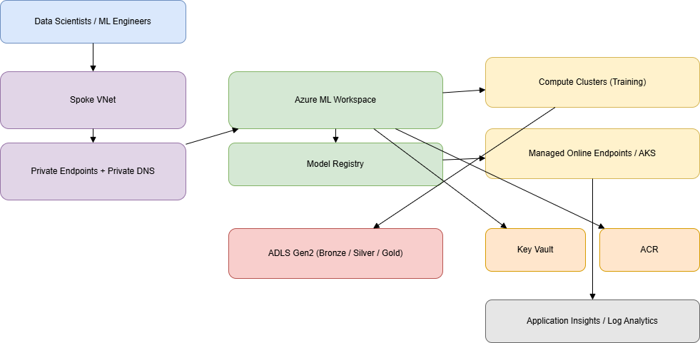

Key Design Decisions
- Private networking only (no public endpoints)
- Centralized model registry
- Separation of dev / test / prod workspaces

4. Subscription, Resource Group & Workspace Strategy

Subscriptions
- Separate subscriptions for Platform, Non-Prod, Prod

Resource Groups
RG Type | Purpose
rg-mdp-aml-platform | Shared services
rg-mdp-aml-dev | Development workloads
rg-mdp-aml-prod | Production workloads

Workspace Isolation
- One AML workspace per environment

5. Networking Standards

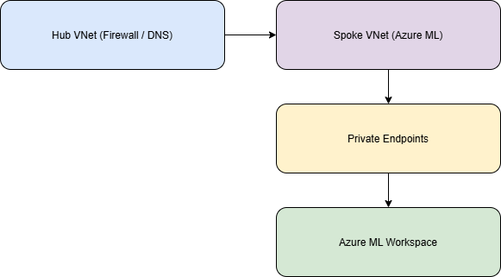

Virtual Network Integration
- AML Workspace with Private Endpoint
- Disable public network access
- Use Hub-Spoke topology

Private Endpoints Required
- Azure ML Workspace
- Storage Account (ADLS Gen2)
- Azure Container Registry
- Key Vault

DNS
- Private DNS zones linked to VNets
- Centralized DNS management

6. Security Best Practices

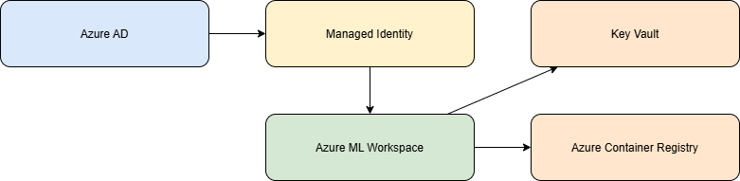

Identity & Access Management
- Azure AD authentication only
- Managed Identities (System or User Assigned)
- No shared keys or secrets

RBAC Model
Role | Scope
Azure ML Admin | Workspace
Azure ML Data Scientist | Workspace
Reader | Subscription

Secrets Management
- All secrets stored in Azure Key Vault
- Never hardcode secrets in code or notebooks

7. Naming Conventions

General Pattern
<org>-<team>-<env>-<service>-<region>-<instance>

Examples
- aml-mdp-dev-mlws-eus-01
- adls-mdp-prod-ml-eus-01
- aks-mdp-prod-ml-eus-01

Model Naming
<project>_<usecase>_<algo>_v<major.minor>

8. Coding Standards

Languages
- Python 3.10+
- Use Azure ML SDK v2

Code Structure
ml-project/
├── data/
├── src/
│ ├── training/
│ ├── inference/
│ ├── features/
│ └── utils/
├── pipelines/
├── tests/
└── environments/

Best Practices
- PEP8 compliance
- Type hints mandatory
- Logging using logging module
- Unit tests required (>75% coverage)

9. Data Preparation Standards

Data Sources
- ADLS Gen2 preferred
- Immutable raw data zone

Data Zones
- Raw (Bronze)
- Processed (Silver)
- Feature-ready (Gold)

Dataset Management
- Use Azure ML Data Assets (v2)
- Version datasets explicitly

11. Training Standards

Compute
- Use compute clusters (auto-scale)
- Spot instances for non-prod

Experiment Tracking
- Mandatory experiment names
- Log parameters, metrics, artifacts

Reproducibility
- Fixed random seeds
- Environment versioning

12. Model Validation & Evaluation

Validation Techniques
- Cross-validation
- Holdout test sets

Metrics
- Business-aligned metrics
- Threshold-based acceptance criteria

Responsible AI
- Bias & fairness checks
- Explainability (SHAP)

13. Model Registry & Governance
- All models registered in AML Registry
- Mandatory metadata:
  - Owner
  - Training data version
  - Metrics
  - Approval status

14. Deployment Standards

Deployment Options
Type | Use Case
Managed Online Endpoint | Real-time
Batch Endpoint | Offline scoring
AKS | High-scale / custom

Deployment Best Practices
- Blue/Green or Canary deployments
- Autoscaling enabled
- Health probes mandatory

15. Inference & Usage

Inference Code
- Stateless services
- Input/output schema validation

Performance
- Model warm-up
- Batch requests preferred

16. CI/CD & MLOps

Tooling
- Azure DevOps or GitHub Actions
- Terraform/Bicep for IaC

Pipelines
- Build: lint, test
- Train: pipeline execution
- Release: model deploy

17. Monitoring & Observability

Metrics
- Latency
- Throughput
- Error rates

Data Drift
- Input data drift detection
- Prediction drift

Logging
- Application Insights
- Central Log Analytics

18. Cost Management
- Auto-scale compute
- Scheduled shutdowns
- Cost alerts per workspace

19. Compliance & Governance
- Audit logs enabled
- Data lineage tracking
- Retention policies

20. Environment-Specific Standards (Dev / Test / Prod)

Development
- Flexible compute sizing
- Spot instances allowed
- Relaxed approval gates
- Rapid experimentation enabled

Test / UAT
- Production-like data schemas
- Performance and load testing
- Security validation

Production
- No public endpoints
- Approval-based deployments
- Autoscaling mandatory
- Strict RBAC and logging

21. AKS vs Managed Online Endpoints Decision Matrix
Criteria | Managed Online Endpoint | AKS
Ops Overhead | Low | High
Custom Networking | Limited | Full
Scale | Medium | Very High
GPU Workloads | Supported | Supported
Recommended For | Most use cases | Regulated / high-scale

22. Infrastructure as Code (IaC) Standards

Tools
- Terraform (preferred)
- Bicep (Azure-native)

Required Coverage
- VNets & Private Endpoints
- AML Workspace
- Compute & AKS
- Role Assignments

State Management
- Remote backend (Azure Storage)
- Environment isolation

23. End-to-End MLOps Architecture
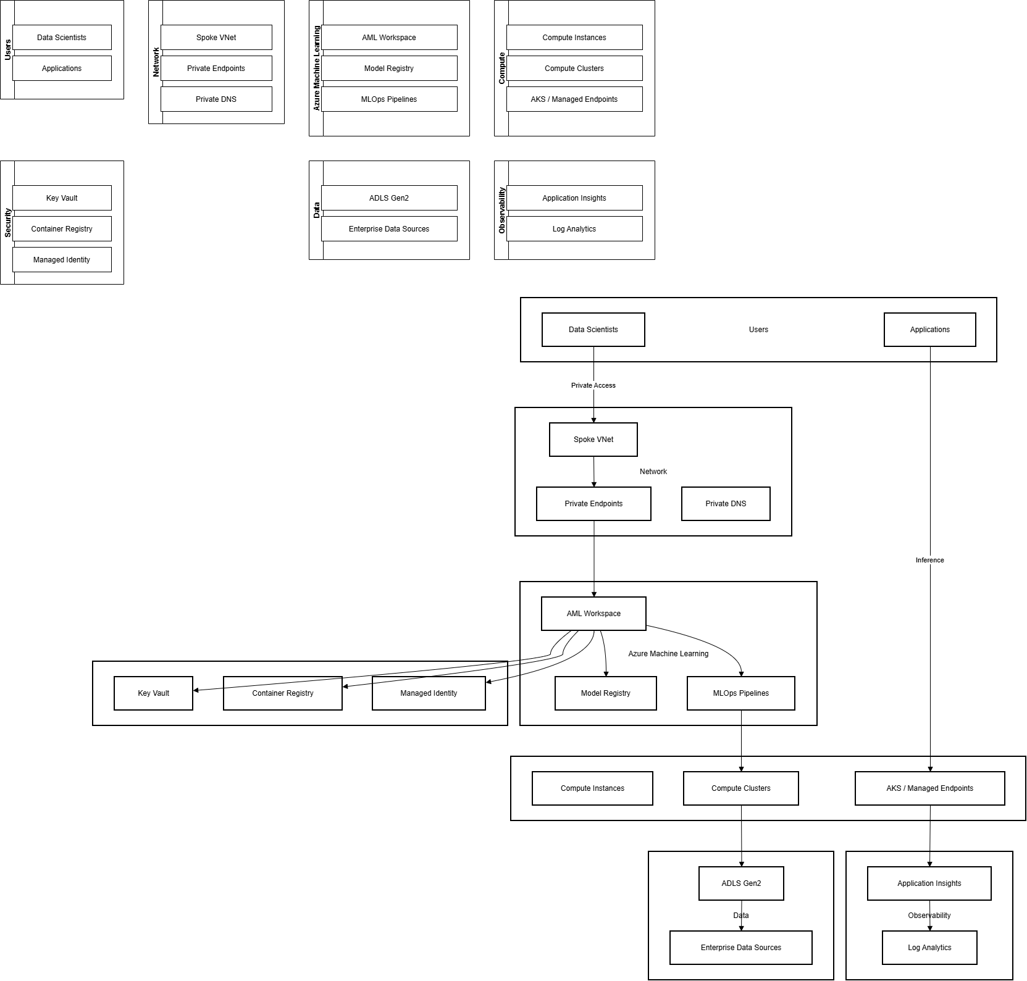

24. Operational Runbooks

Model Rollback
- Use previous model version
- Automated redeploy via pipeline

Incident Response
- Disable endpoint
- Alert on-call
- Root cause analysis

Data Drift Response
- Retrain pipeline trigger
- Business owner notification

25. Azure Policy & Defender Controls

Mandatory Policies
- Deny public endpoints
- Enforce private DNS
- Require Managed Identity

Defender for Cloud
- Container vulnerability scanning
- Storage threat protection

26. Enterprise Quality Gates

Data
- Schema validation
- Data freshness

Model
- Metric thresholds
- Bias checks

Deployment
- Load test pass
- Security sign-off

27. Reference Repository Structure
azure-ml-platform/
├── iac/
├── ml-project-template/
├── pipelines/
├── runbooks/
└── docs/

28. Enterprise Readiness Checklist
- Security review completed
- IaC deployed
- Monitoring enabled
- Cost alerts configured
- Go-live approval

